The conference will take place at Institute of Thermomechanics, Czech Academy of Sciences, Dolejškova 5, Praha 8.
(http://www.it.cas.cz/en/contacts)
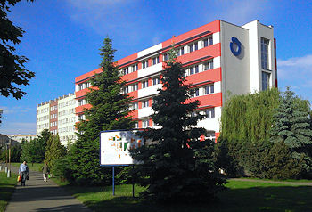

The institute is located within the campus of academic institutions in the city district called Ládví. It is easily reachable from the city center by the underground line C, station Ládví.
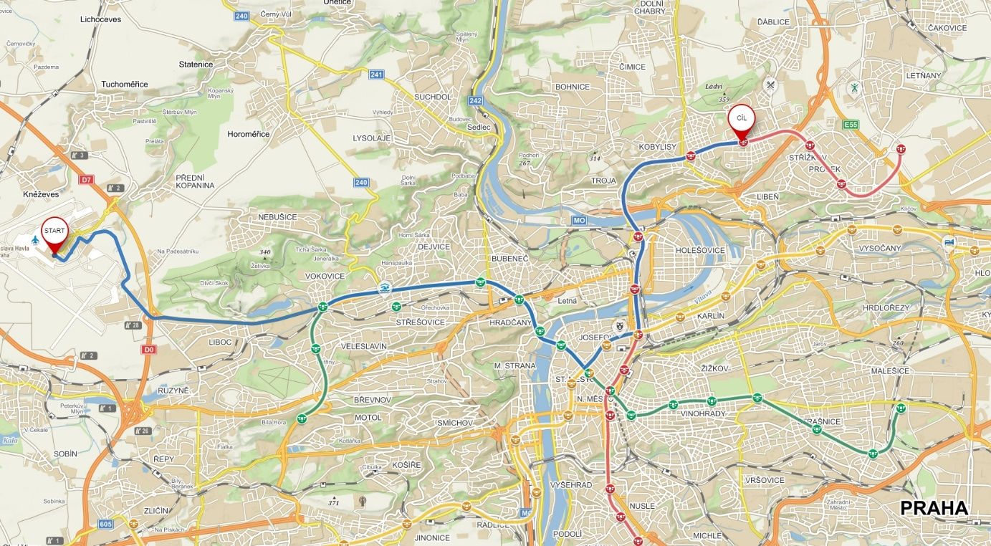

For useful information about Prague (not only transport), please visit:

http://www.praguewelcome.cz/en/

The Czech Koruna (1EUR = approx. 25 CZK) is used as a currency in the Czech Republic. Euro is usually accepted by hotels and big shops but with a less favorable exchange rate. Ask in advance.
raveling by city transport is possible only with a valid ticket. Passengers have to purchase their tickets before boarding the vehicle or entering the underground (Metro) system. The paper ticket is valid only if it is marked in the validation machine. Tickets can be bought at Metro stations or in the information centers, hotels, newsstands, and in the ticket vending machines located at the Metro stations or near some stops of surface transport.
However, if you do not need a paper ticket, the easiest and fastest way how to get the ticket is via the mobile application PID Litacka on your phone. The app is in Czech as well as English. You can also buy the ticket using the app in advance and validate it using the app at least 2 minutes before entering the public transport.
You can search for connections on Public Transport web pages or in the mobile application PID Litacka..

Fares

Single-trip tickets
40 CZK - basic
the ticket is designated for the underground, trams, and buses and is valid for 90 minutes after marking
30 CZK - basic
the ticket is designated for the underground, trams, and buses and is valid for 30 minutes after marking

Short-term tourist tickets
- 24 hours ticket 120 CZK
- 3 days 330 CZK
These tickets are valid for all means of the city transport from the moment of their marking. They can be bought in the Information Centers of the Prague Public Transport Company or using the app.

Freight
- Luggage bigger than 25x45x70 cm 20 CZK

Ticket Inspection
The validity of tickets can be checked by the ticket inspectors of Dopravní podnik at any time during the travel. The ticket inspector is entitled to ask the passenger to produce his or her valid ticket, to confiscate invalid tickets, and to collect a penalty (1500 CZK, if paid at once 1000 CZK) in the case of travel without a valid ticket. In case of unpaid luggage, the inspector collects the penalty 400 CZK, which is reduced to 200 CZK, if it is paid on the spot or in the supplementary fare office of Dopravni podnik. To prove their identity, inspectors produce yellow-and-red badges. They issue receipts for the penalty amounts.

The transportation from the airport to the institute:

Possibility 1:

Buy a single ticket for 40 CZK, if you have big luggage (bigger than 25x45x70 cm) also 20 CZK for it. After getting to the bus, validate it in the yellow box. It will be valid for the entire journey, which will take you approx. 70 min.
Take the bus line № 119 from Prague Airport to Nádraží-Veleslavín Metro Station –15 min. Then take the Metro line A to Muzeum Station – 10 min. Exchange for Metro line C to Ládví station – 13 min.
Or
Take the bus line № 100 from Prague Airport to Zličín Metro Station –18 min. Then take the Metro line B to Florenc Station – 25 min. Exchange for Metro line C to Ladvi – 9 min.
Possibility 2:
Special barrier-free line AE - Airport Express from the Prague Airport to the Main Railway Station. Fare is 100 CZK, the ticket can be bought at the DPP kiosk at the airport or from a driver, travel time approx. 40 min. Then exchange for Metro line C to Ladvi station – 11 min. You must additionally validate the 30-CZK ticket at the Metro entrance.
Possibility 3:
By taxi. Prague is infamous for overpriced taxi services for foreigners. This can be overcome by utilizing the worldwide taxi service called UBER (application on the phone or via www page Uber). The approximate price from the airport to the conference venue is 410 CZK (depends on the time of order and the type of UBER taxi chosen). The proof of payment by UBER is sent after the route to your email.
If you choose a traditional taxi, if possible, please order the taxi in advance. Only then you will get better prices and minimize the chance to be treated unfairly. You can find links for taxi services in Prague below.
http://www.prague.eu/en/practical
http://en.modryandel.cz/

